` | 
ADDENDUM TO COUNCIL ASSESSMENT REPORT
NORTHERN REGIONAL PLANNING PANEL

PANEL REFERENCE & DA NUMBER | PPSNTH-288 (DA 2023/046)
LGA | Gunnedah Shire Council
PROPOSED DEVELOPMENT | Operation of an Extractive Industry (Gravel Quarry), 40,000 Tonnes per annum and total volume 734,000 Tonnes
ADDRESS | Lot 139 DP 751012, 809 Oakey Creek Road, Piallaway
APPLICANT | Mr Gary Peacock of Outline Planning Consultants on behalf of Gunnedah Shire Council
OWNER | Mr Michael Edward Bolger leasing the quarry site to Gunnedah Shire Council
DA LODGEMENT DATE | 20 July 2023
APPLICATION TYPE | Integrated & Designated Development
CIV | $10,000.00 (excluding GST)
RECOMMENDATION | Approval
REPORT PREPARED BY | Lillian Charlesworth, Manager RSD Assessment, Department of Planning, Housing and Infrastructure (on behalf of Gunnedah Shire Council).
DATE OF REPORT | 22 July 2025

PANEL DEFERRAL
On 19 June 2025 the SNPP deferred a decision on this development application to allow for the provision and assessment of the following information:
- Updated comprehensive site plan including the location of the sump and updated vehicular turning areas
- Updated General Terms of Approval from the NSW EPA which are consistent with the updated Site Plan
- Further site investigations and bore testing for ground water penetration to specify the location and depth of the groundwater table within the sump footprint to ensure that:
- there is no interaction or penetration of water within the sump with groundwater; and
- finished surface levels to the base of the sump do not extend below the groundwater table
These matters are each addressed below.
SITE PLAN
An RFI was issued (after being viewed by the Panel), and the Applicant provided a Site Plan (consisting of 6 sheets) on 16 July 2025 consistent with the 4-week RFI response timeframe indicated. The Site Plan has been reviewed and is generally consistent with the detailed list of items requested to be shown on the Plan.
Car Parking
It’s noted that the Site Plan provides for 4 car parking spaces to meet the needs of quarry staff, rather than the 7 parking spaces indicated in the assessment report to allow additional parking for contractors and visitors. Therefore the draft conditions have been amended to require 7 car parking spaces.
Stage 1 Rehabilitation Area
The Final Assessment Report recommended staged rehabilitation of the site, with Stage 1 being an approximately 0.7ha disturbed area of former quarry works (Figure 1) to be rehabilitated within12months of commencement of operations. 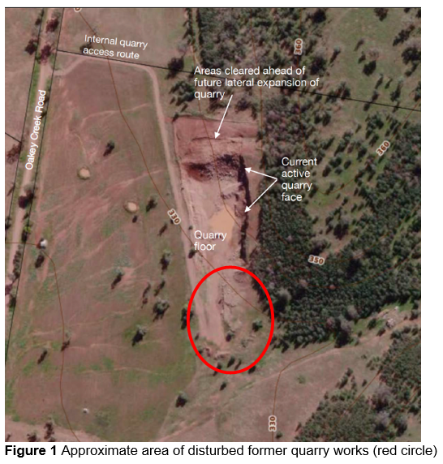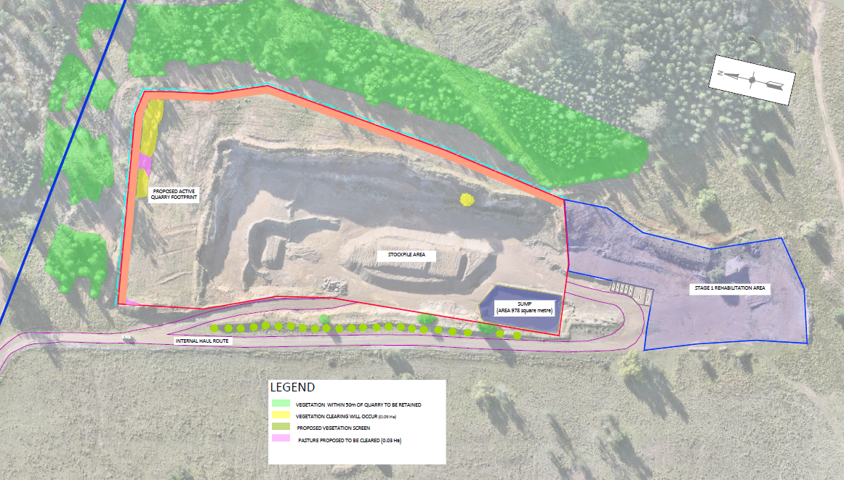
Figure 2. Proposed Stage 1 Rehabilitation Area (shown purple)
The Applicant indicated that part of this nominated area is required for internal site access and therefore has instead proposed that Stage 1 consist of the area shown coloured purple in Figure 2. The aerial image in Figure 2 clearly shows that the internal access road needs to avoid a mound extending south from the sump and therefore this part of the site is still required for operational activities. The area indicated for Stage 1 in Figure 2 is a positive environmental outcome, as the entire area of disturbed land no longer required by the quarry (which remains 0.7ha in area) will benefit from early rehabilitation.

EPA GTA’s
The Site Plan was forwarded to the EPA on 17 July 2025 with a request to provide revised GTAs if needed. It was highlighted that the location of the sump on the Site Plan is shown the south-west corner of the site, whereas it is shown at the south-east corner of the site in the EIS. The Applicant indicated that the sump is currently located in the south-west corner of the site and there is no intention for it to be relocated, despite the EIS. It was also highlighted to the EPA that the site disturbance area of 2.71ha has not changed, although this figure does not include the internal haul road.
A response was received from the EPA dated 21 July 2025 to advise that there are no changes required to the issued GTA’s.
GROUNDWATER DRILLING
On 22 July 2025 the Applicant submitted a report from Precision Drill and Blast (Appendix 2) with the results of drilling three (3) bore holes to ascertain if groundwater would be intercepted by the proposed quarry activities. Drilling occurred in close proximity to the sump location to a depth of 10m and no groundwater was found. The EIS and the Water Balance Assessment indicate that the quarry floor is currently at RL325 in the area of the sump. A 10m drilling depth would therefore mean that drilling was undertaken to a depth of approximately RL315 which is 3m below the maximum proposed depth i.e. RL318 for the floor of the sump located 2m below the quarry floor.
The proposed quarry activity will therefore not have any impact on groundwater.
REVISED DRAFT CONDITIONS OF CONSENT
As a result of discussions at the Panel briefing held 19 June 2025 and the provision of additional information subsequent to the briefing, the following changes to the draft conditions of consent are proposed:
General Matters: Add a description of the approved development.
Condition 1. Add the Site Plan and Drilling Report.
Condition 2. Delete and replace with a requirement to submit an amended Site Layout Plan showing 7 car parking spaces.
Prior to Quarry Activities Commencing: Add a requirement for certification to ensure that there is oversight across all aspects required to be in place prior to the commencement of operations.
Condition 9. The boundaries of the Stage 1 Rehabilitation Area are to be delineated on the ground by survey markers.
Conditions 11, 12 and 39. Indicate that the Quarry Environmental Management Plan and Quarry Rehabilitation Management Plan and Annual Progress Reports during the rehabilitation implementation period are to be prepared by an independent expert (rather than Council staff).
Condition 11(b)(iii). In response to comments from the Applicant dated 16 June 2025, it is agreed to remove the requirement for 6 months of background air quality monitoring prior to the commencement of quarry operations.
Condition 15. Require that the 7 parking spaces be adequately surfaced and delineated.
Condition 39. Set a six (6) week timeframe for submission of Annual Progress Reports during the rehabilitation implementation period for each Stage of rehabilitation.
A few other minor edits have been made to update numbering, correct typos or add clarity.
CONCLUSION
All outstanding matters raised in the Panel’s Record of Deferral have now been satisfied as additional information provided by the Applicant has indicated that groundwater penetration is not an issue, no change is needed to the EPA GTA’s and the submitted Site Plan has added an additional level of certainty and clarity regarding the nature of the proposal. The development application is recommended for approval subject to the amended conditions at Appendix 3.

APPENDICES
Appendix 1 – Site Plan
Appendix 2 – Groundwater Test Drilling
Appendix 3 – Revised Draft Conditions of Consent

